[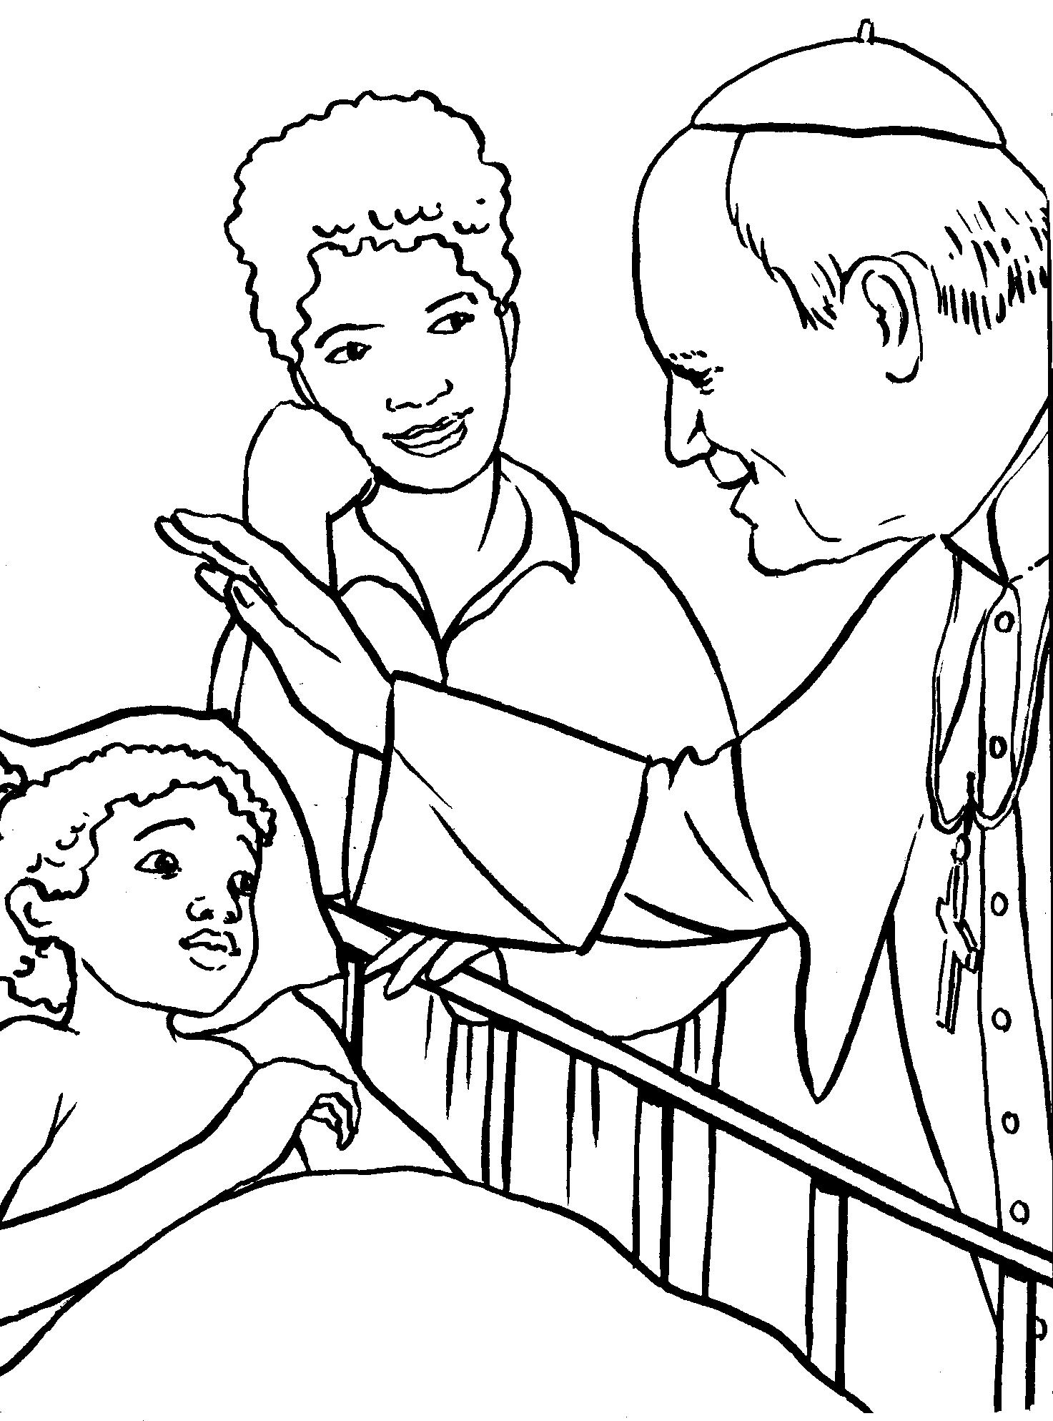](https://www.google.pl/url?sa=i&url=https://wduchuswietym.com/pobieralnia/category/17-jan-pawel-ii&psig=AOvVaw3g8t6iGoXj4RPdbRJ5OWjx&ust=1585901779414000&source=images&cd=vfe&ved=0CAIQjRxqFwoTCPCdq7-nyegCFQAAAAAdAAAAABAs)